Data Structure and Algorithm
Laboratory Activity No. 14

Tree Structure Analysis

Submitted by: | Instructor:
Gabuyo, Ivan love D. | Engr. Maria Rizette H. Sayo

November. 8, 2025

Objectives
Introduction
An abstract non-linear data type with a hierarchy-based structure is a tree. It is made up of links connecting nodes (where the data is kept). The root node of a tree data structure is where all other nodes and subtrees are connected to the root.

This laboratory activity aims to implement the principles and techniques in:
- To introduce Tree as Non-linear data structure
- To implement pre-order, in-order, and post-order of a binary tree
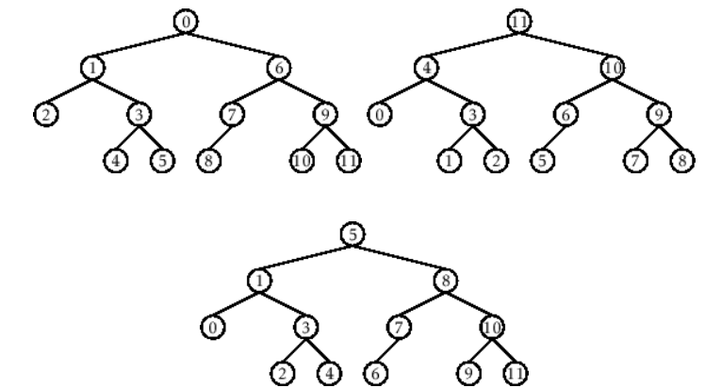

- Figure 1. Pre-order, In-order, and Post-order numberings of a binary tree

Methods
  - Copy and run the Python source codes.
  - If there is an algorithm error/s, debug the source codes.
  - Save these source codes to your GitHub.
  - Show the output

    - Tree Implementation

class TreeNode:
def __init__(self, value):
self.value = value
self.children = []

def add_child(self, child_node):
self.children.append(child_node)

def remove_child(self, child_node):
self.children = [child for child in self.children if child != child_node]

def traverse(self):
nodes = [self]
while nodes:
current_node = nodes.pop()
print(current_node.value)
nodes.extend(current_node.children)

def __str__(self, level=0):
ret = " " * level + str(self.value) + "\n"
for child in self.children:
ret += child.__str__(level + 1)
return ret

# Create a tree
root = TreeNode("Root")
child1 = TreeNode("Child 1")
child2 = TreeNode("Child 2")
grandchild1 = TreeNode("Grandchild 1")
grandchild2 = TreeNode("Grandchild 2")

root.add_child(child1)
root.add_child(child2)
child1.add_child(grandchild1)
child2.add_child(grandchild2)

print("Tree structure:")
print(root)

print("\nTraversal:")
root.traverse()

Questions:
- What is the main difference between a binary tree and a general tree?
The main difference between a binary tree and a general tree (like the one in the image) is that a binary tree allows each node to have at most two children, while a general tree (as shown) can have more than two children, such as a root with multiple children and grandchildren.

- In a Binary Search Tree, where would you find the minimum value? Where would you find the maximum value?
In a Binary Search Tree (BST), the minimum value is found by going to the leftmost node from the root, while the maximum value is found by going to the rightmost node. Although the image doesn’t show a BST, that’s how it works conceptually.
- How does a complete binary tree differ from a full binary tree?
A complete binary tree has all levels completely filled except possibly the last, and all nodes are as far left as possible. A full binary tree has every node with either 0 or 2 children — in contrast, the tree in the image is a general tree, not necessarily complete or full.

- What tree traversal method would you use to delete a tree properly? Modify the source codes.

To delete a tree properly, you should use a postorder traversal, which means deleting all children before deleting the parent. In the image, that order would be:
- Grandchild 1
- Child 1
- Grandchild 2
- Child 2
- Root

Results
Present the visualized procedures done. Also present the results with corresponding data visualizations such as graphs, charts, tables, or image . Please provide insights, commentaries, or explanations regarding the data. If an explanation requires the support of literature such as academic journals, books, magazines, reports, or web articles please cite and reference them using the IEEE format.
Please take note of the styles on the style ribbon as these would serve as the style format of this laboratory report. The body style is Times New Roman size 12, line spacing: 1.5. Body text should be in Justified alignment, while captions should be center-aligned. Images should be readable and include captions. Please refer to the sample below:

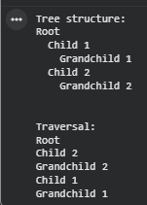

Figure 1 Screenshot of program
If an image is taken from another literature or intellectual property, please cite them accordingly in the caption. Always keep in mind the Honor Code [1] of our course to prevent failure due to academic dishonesty.

Conclusion
In this lab, I learned that there are many types of trees, general trees, binary trees, and binary search trees, each with different rules and uses. I also learned where to find the minimum and maximum values in a binary search tree, how to tell the difference between full and complete binary trees, and why post-order traversal is best for deleting a tree. Overall, this activity helped me understand how trees are structured and how they are used to organize data in computer systems.
References
[1] Programiz, “Binary Tree and Its Types,” Programiz, 2024. [Online]. Available: https://www.programiz.com/dsa/binary-tree

